**Phase 5**

**Lesson 3**

**launch_and_connect_to_an_ec2_linux_instance**

**steps:**

1. Go to Amazon dashboard / Select EC2

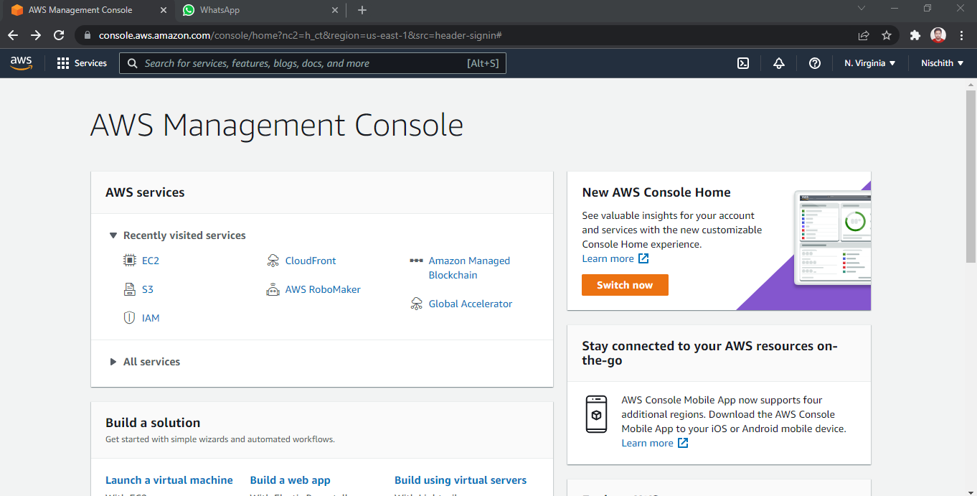

1. Click on *launch instance* to run any instance

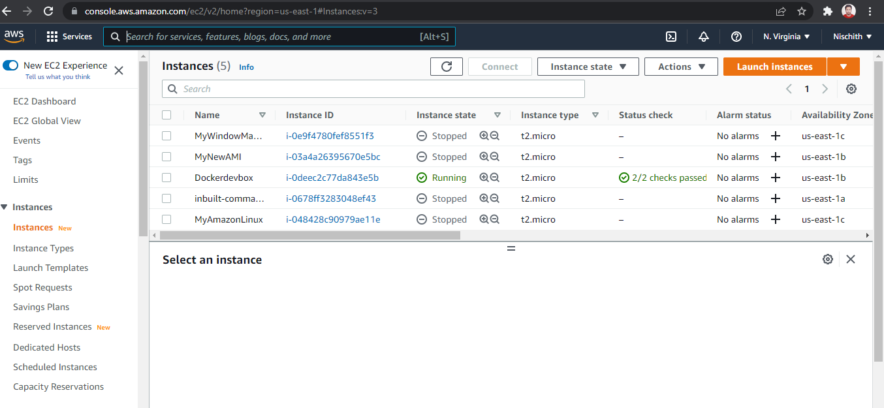

1. Select the AMI

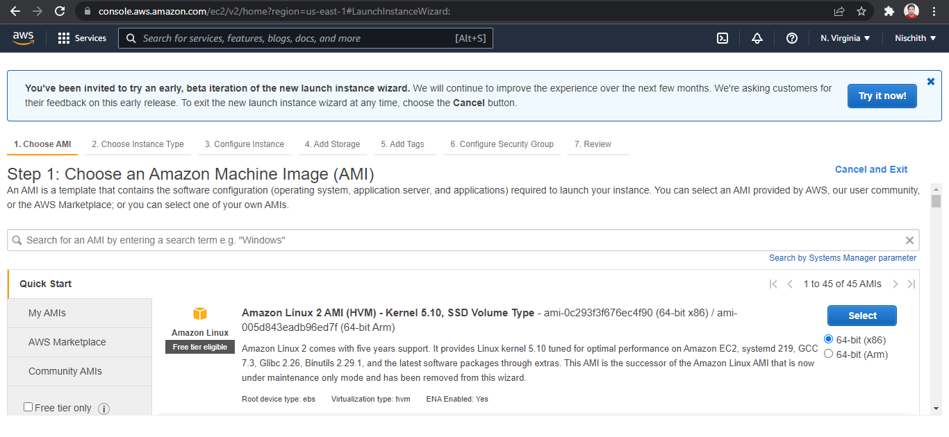

1. Select t2.micro as the instance type

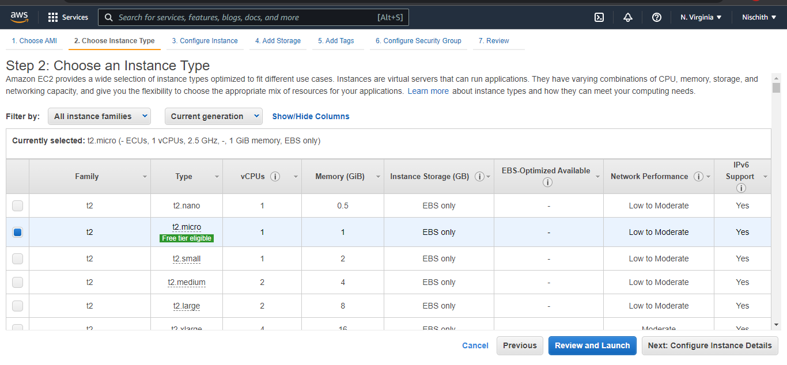

1. Specify the number of instances, networks, placement groups, and IAM roles and click *Next*

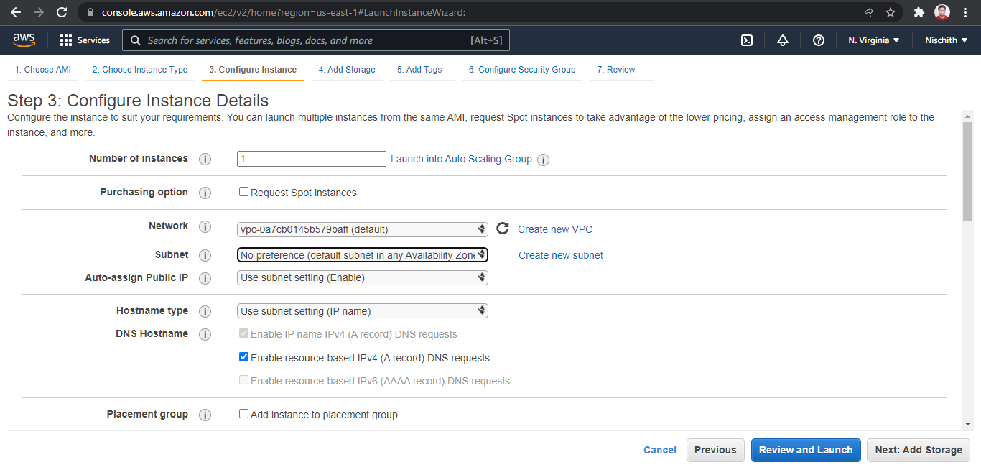

1. There is one volume attached to the instance by default

In Linux, the default volume attached is 8 GB

You can add more volume if required

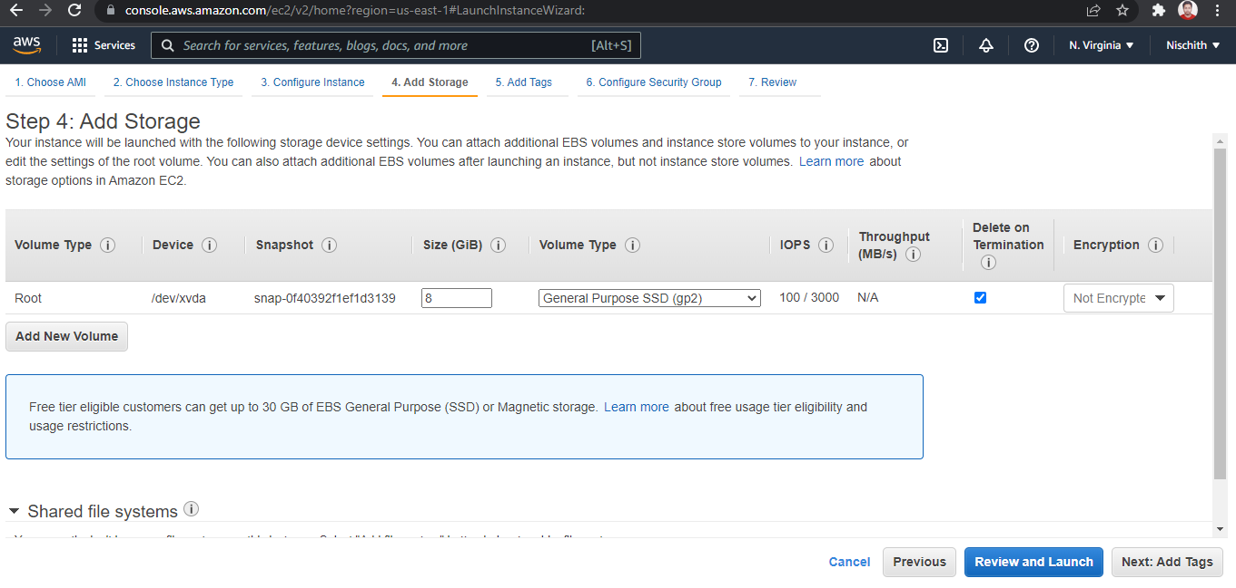

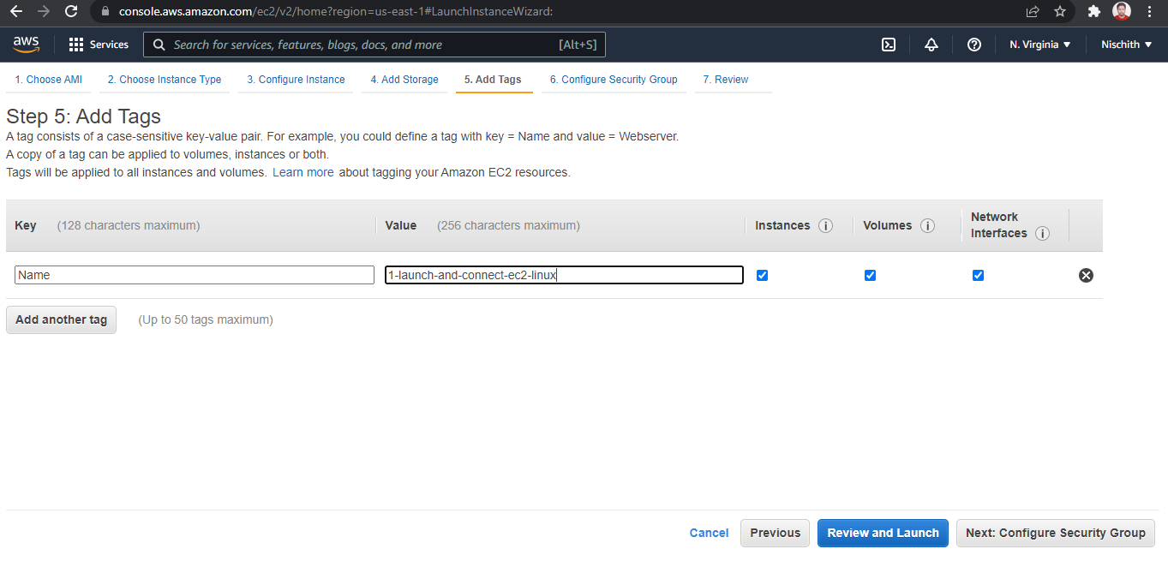

1. You can add a key-value pair to the instance
2. Attach the three policy groups depending on the type of access required

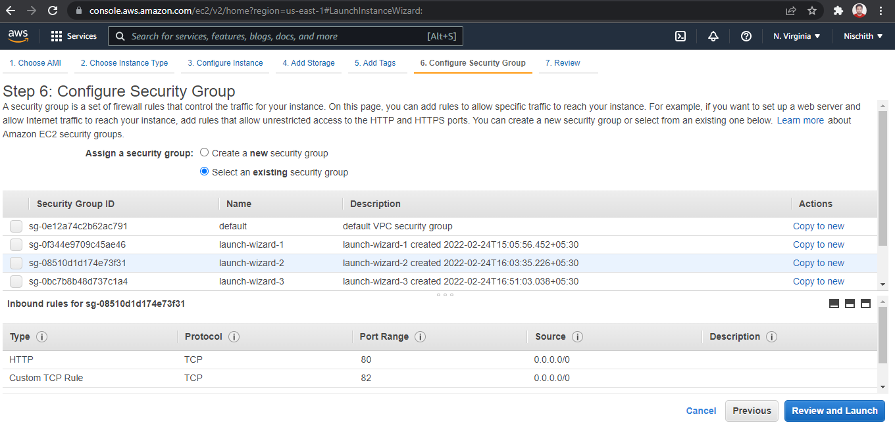

1. Select an existing key-value pair to launch the instance
2. The instance is ready to use

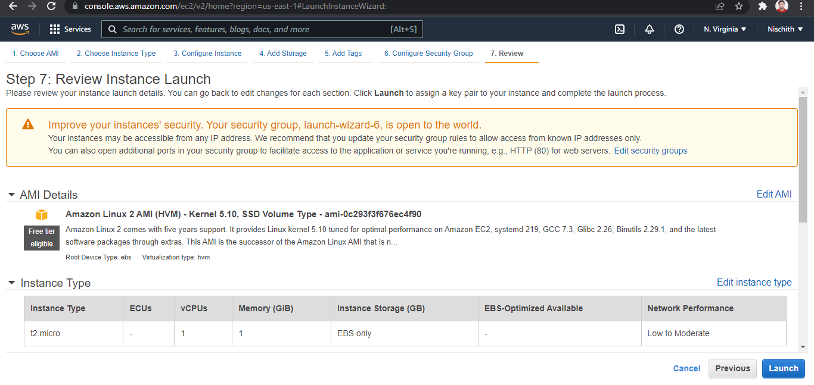

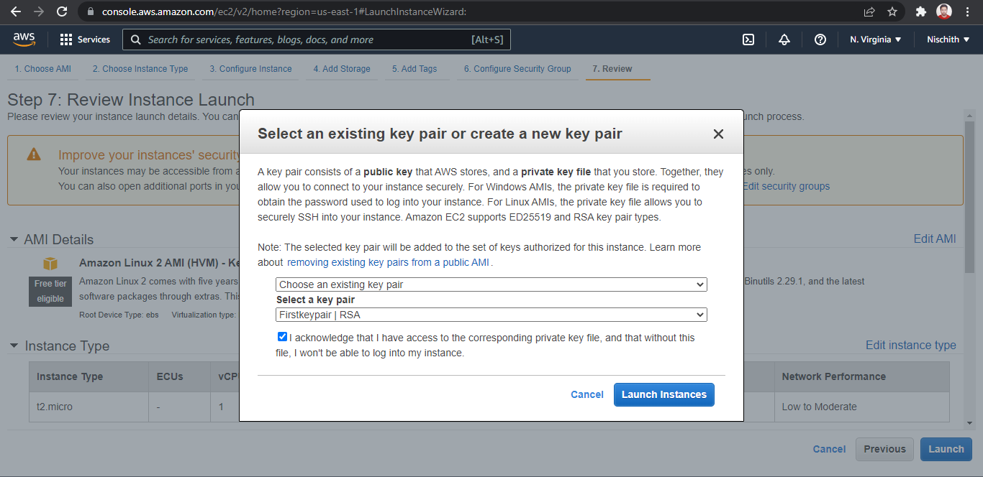

1. Click on *Connect* on EC2 dashboard

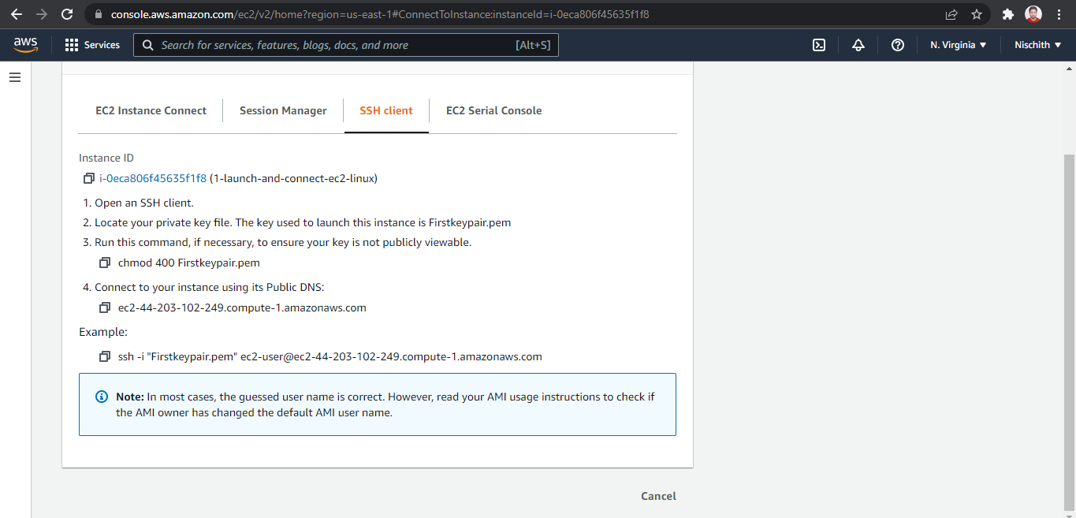

1. Run the ssh command provided

Connecting to an EC2 instance

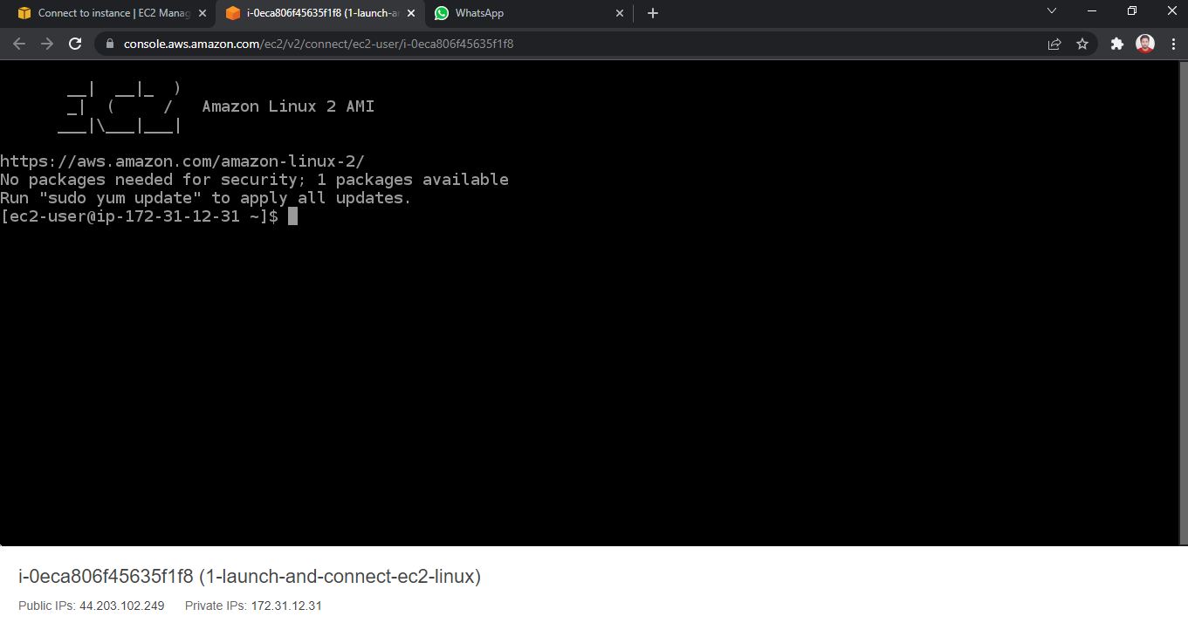

1. Run the following command to launch a website over EC2:

Sudo yum update –y

Sudo yun install –y httpd

Sudo systemctl start httpd

Sudo systemctl enable httpd

Sudo chmod 0777 /var/www/html

Sudo echo “<html><h1> hello world </h1></html>” > /var/www/html/index.html

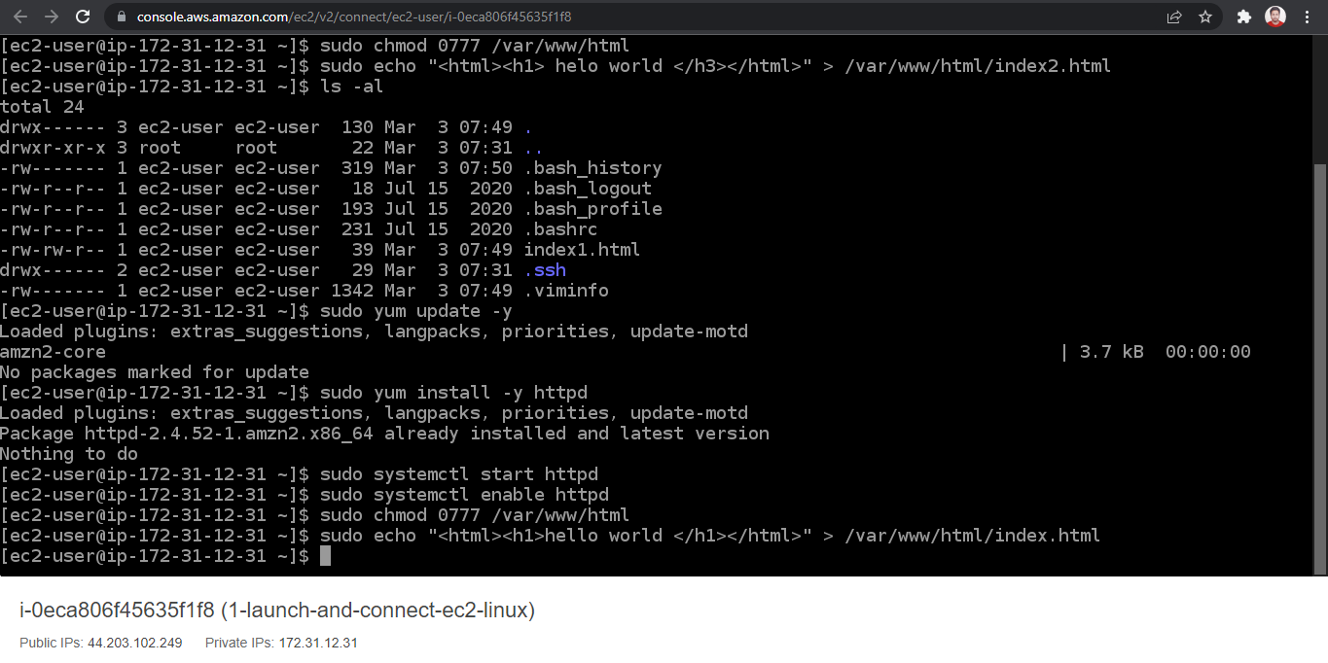

1. Using public IP of EC2 instance, you can see your app running on the browser

